**PCB Design.**

A printed circuit board (PCB) mechanically supports and electrically connects electrical or electronic components using conductive tracks, pads and other features etched from one or more sheet layers of copper laminated onto and/or between sheet layers of a non-conductive substrate. Components are generally soldered onto the PCB to both electrically connect and mechanically fasten them to it.

After the introduction, we are starting to mention about the process, challenges and solution of these challenges in flyback PCB design.

In this project, we have used Kicad pcb design tool to implement the design. Firstly all of the schematic of the circuit is implement by using the symbols. This process is important because we will next generate a netlist from these connections and later on, we will import this netlist in the PCB design layout.

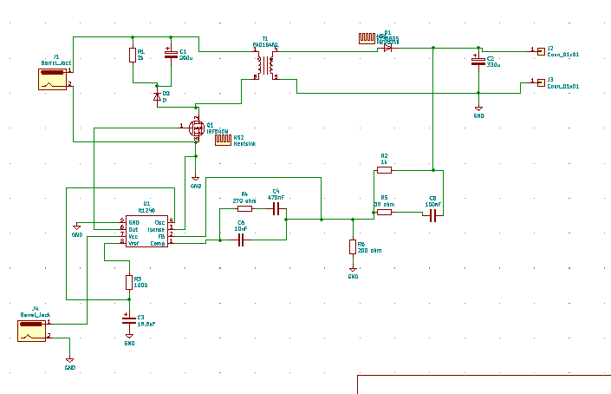

FigureXX: schematic of the Flyback circuit.

As we can see from the figure all the connections between the components are done however, although it can not be understood from the figure, we have faced with several challenges in the implementation of this process because there isn’t any LT1246 symbol in the Kicad libraries thus, we had to make it ourselves, for that purpose, Symbol editor tool of the kicad is utilized to create that symbol because we have the data sheet and we know how many pins that we need to create that block.

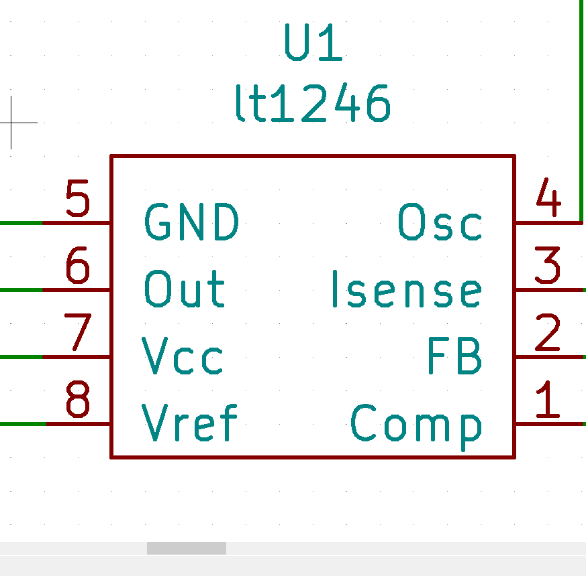

FigureXX:symbol of the “LT1246” Controller ic.

After implementing the missing component symbol, placing resistor and capacitor symbols are straight forward. Therefore, in the next step, after completing the connections of the symbols, in the same page, we have started to assign footprints to symbols. And since, we have chosen nearly all of the components from digikey, this process was also straight forward but in ordert to assign a footprint to “Controller ic” we need to check its datasheet because there was not recommended assignment for that component.

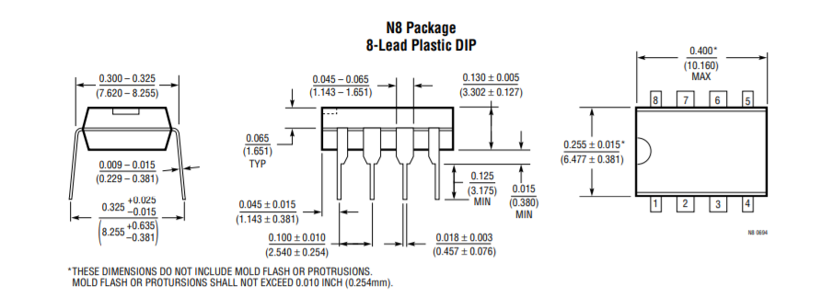

FigureXX:Package information of Lt1246.

In datasheet of that component, we have the package information and its package is common THT SO-DIP-8 package which can be seen for the most of the opamps, therefore it was available in the Kicad footprint library and it was assigned to that footprint.

After assigning of footprints, we have run the “electric rules checker” tool to see whether we can have any connection problems, after observing the checker, we have generated a netlist to export in to “layout” page.

In the second step, we were working on “PCB_Layout” page to adjusting main PCB design, in that page we have created several types of tracks for the connection of the components in terms of how much current that these tracks will carry. In order to evaluate these track widths

we have used “PCB track width calculator” webpage.

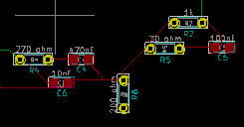

FigureXX: A view from the PCB layout page.

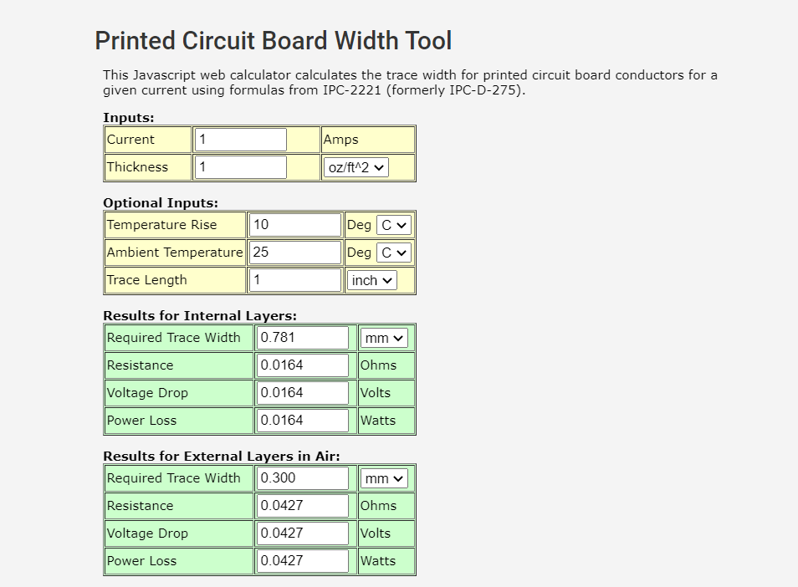

FigureXX: captured when the controller output to gate connection width calculated.

After Calculating the track widths of all the connections, footprints are connected to each other. However, since the implementation of PCB design requires back and front copper layers, we have utilized from this process in several ways. For example since it is hard to jump a connection on another one in the PCB, we have used “back copper” layer for some connections to avoid wrong nodes and connections.

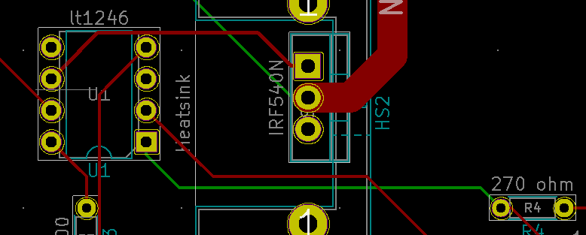

FigureXX: illustration of back and front copper traces.

After checking the design warning and mistakes which is created by “design rules checker”, finally, we have connected all the grounds of the circuits by using front and copper layers. so, the layout process is completed.

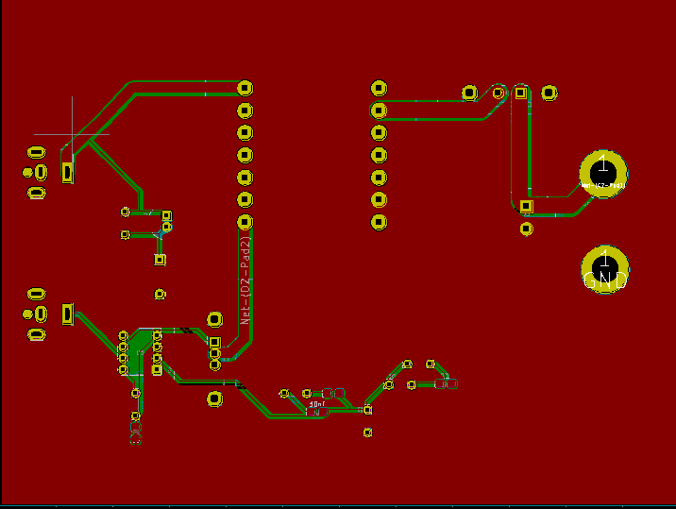

FigureXX: Finalized version of the PCB layout page

After we have created all the layers inside the “Flyback” converter, next process is producing “gerber files” to make the PCB ready to be produced and it can be done using “plot” button of the PCB layout page and following several straightforward steps.

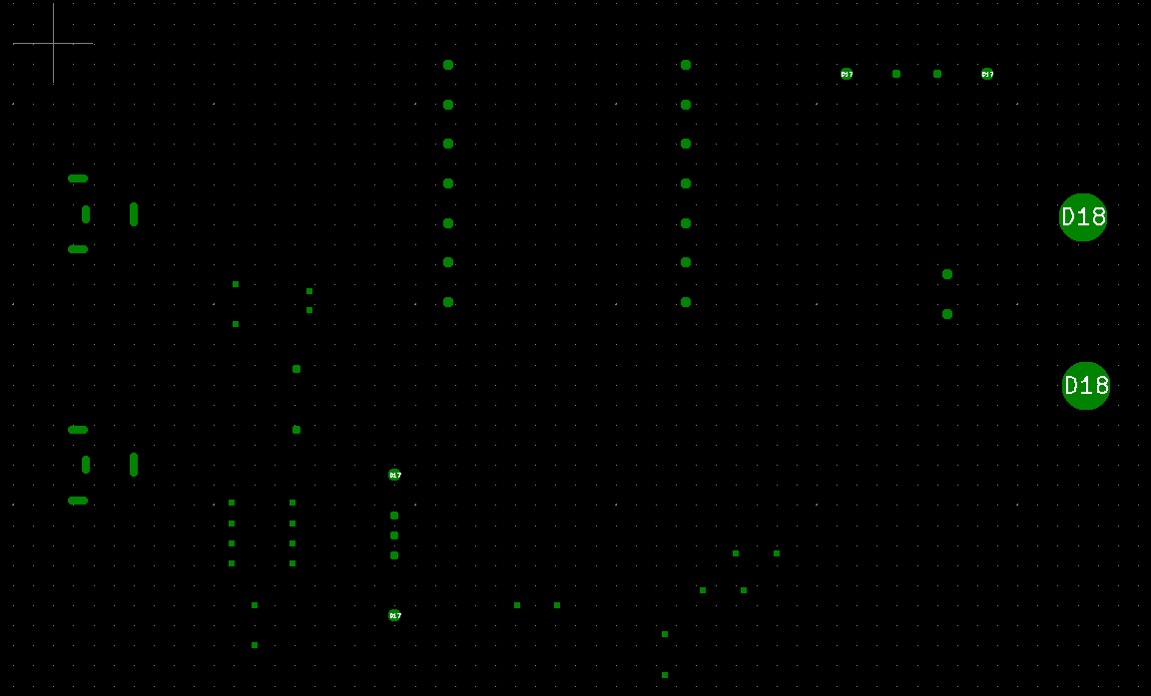

FigureXX: opening “gerb view of drill files.”

And finally, we have taken a quote from the given website. (Bill of materials is on the github)

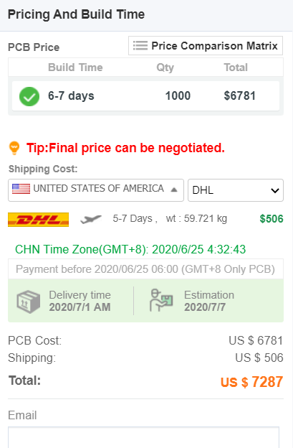

**3d view of the design.**

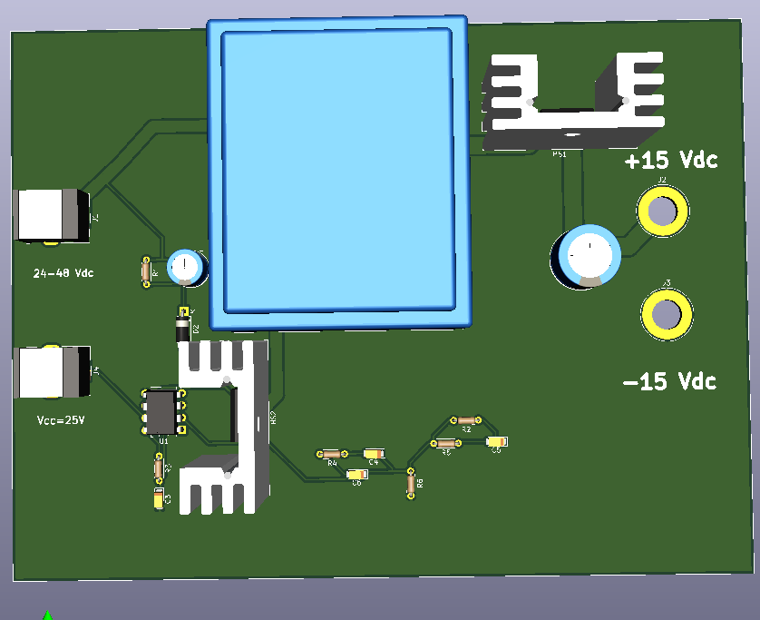

FigureXX: Circuit from top view

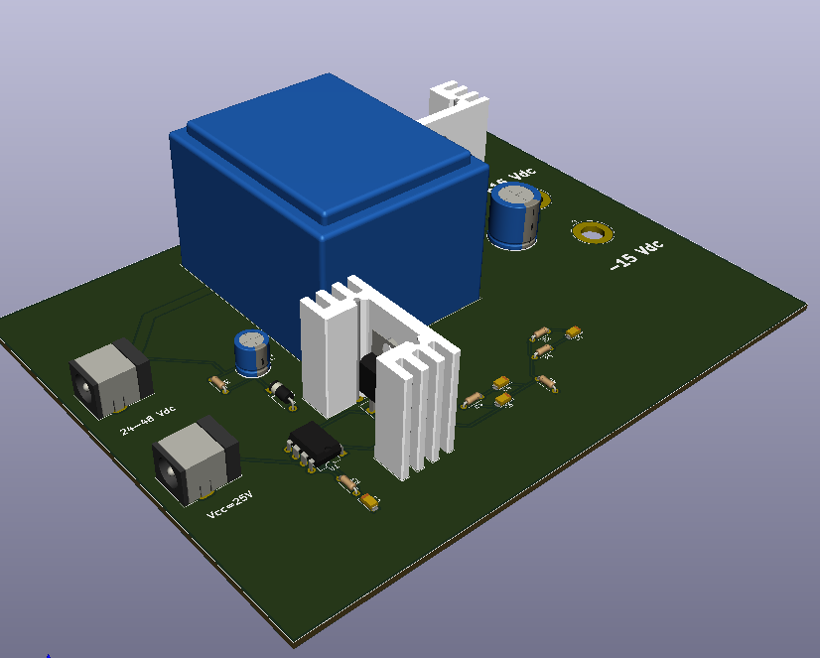

FigureXX: general view of the circuit.